Project Design Phase
Solution Architecture

Date | 3 October 2026
Team ID | SWTID-2026-3708
Project Name | Streamlining IT Procurement: Automating Standard Laptop Orders with Flow Designer
Maximum Marks | 4 Marks

Solution Architecture:
Solution architecture is a complex process – with many sub-processes – that bridges the gap between business problems and technology solutions. Its goals are to:
- Find the best tech solution to solve existing business problems.
- Describe the structure, characteristics, behavior, and other aspects of the software to project stakeholders.
- Define features, development phases, and solution requirements.
- Provide specifications according to which the solution is defined, managed, and delivered.

Solution Architecture Diagram:

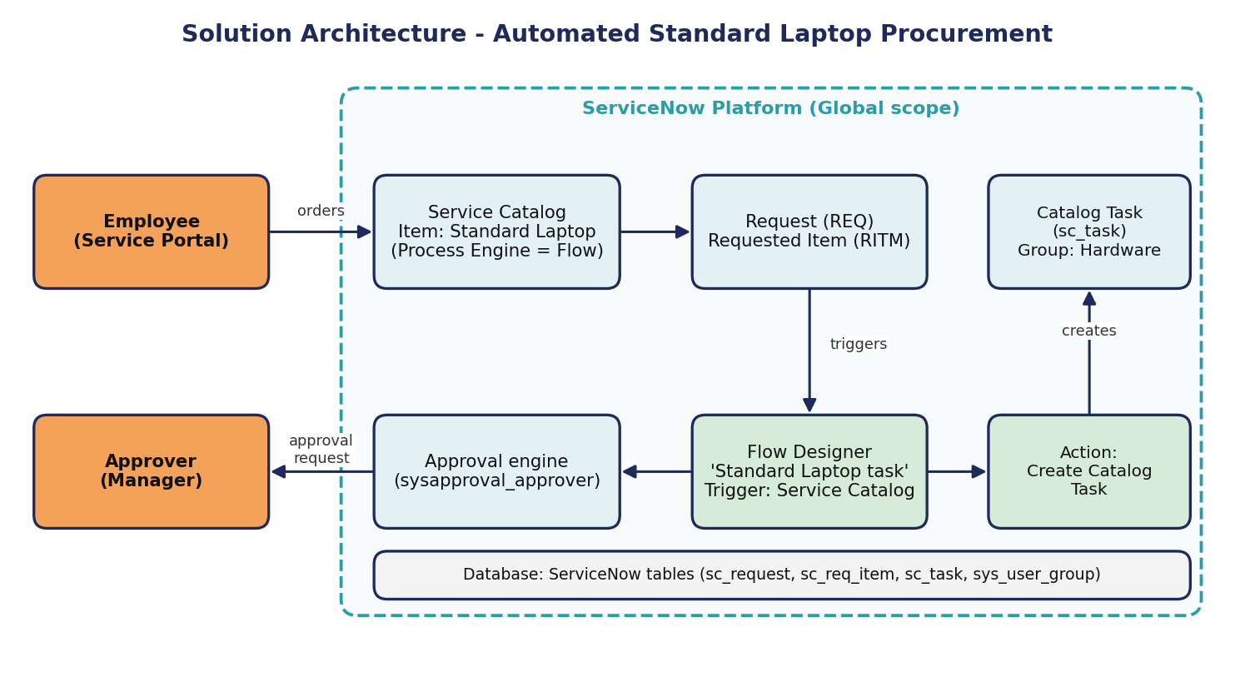
Figure 1: Architecture and data flow of the automated Standard Laptop procurement flow
Architecture description:
1. The employee opens Service Catalog > Hardware > Standard Laptop and clicks Order Now.
2. ServiceNow creates a Request (REQ) and a Requested Item (RITM); the approval engine sends the approval to the manager.
3. The flow 'Standard Laptop task' (attached through the catalog item's Process Engine tab) is triggered by the Service Catalog trigger.
4. The Create Catalog Task action creates a Catalog Task (sc_task) linked to the Requested Item with short description 'Laptop needs to Configured', assignment group Hardware and approval Approved.
5. The Hardware team sees the task in its queue, configures the laptop and closes the task; the status is visible on the Requested Item.

